**Week 10 – Tutorial Assignment**

**SIMPLE PYTHON PROGRAM TO IMPLEMENT FUNCTIONS**

**1. Write a python program to calculate the sum of Two numbers and Three numbers. However, if the sum is between 120 to 320 it will return 200.**

def calculate_sum(numbers):

total = sum(numbers)

if 120 <= total <= 320:

return 200

else:

return total

def main():

num_count = int(input("Enter the number of values (2 or 3):"))

if num_count == 2:

num1 = float(input("Enter the first number:"))

num2 = float(input("Enter the second number:"))

result = calculate_sum([num1, num2])

elif num_count == 3:

num1 = float(input("Enter the first number:"))

num2 = float(input("Enter the second number:"))

num3 = float(input("Enter the third number:"))

result = calculate_sum([num1, num2, num3])

else:

print("Invalid number count")

print(f"Result:{result}")

main()

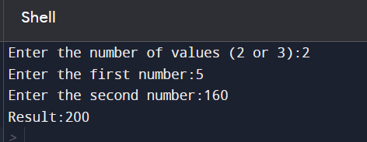

**2. Implement a python function to find the Maximum of Three numbers.**

def find_maximum_of_three_numbers(num1, num2, num3):

return max(num1, num2, num3)

def main():

print("Trishita Yadav\nRA2211003011325")

try:

num1 = float(input("Enter the first number:"))

num2 = float(input("Enter the second number:"))

num3 = float(input("Enter the third number:"))

except ValueError:

print("Invalid input")

return

maximum = find_maximum_of_three_numbers(num1, num2, num3)

print(f"MAX: {maximum}")

main()

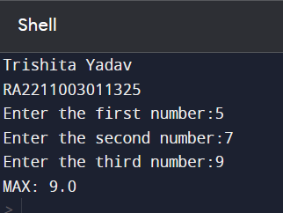

**3. Write a python program to calculate the Factorial of a given number.**

def factorial(n):

if n == 0:

return 1

else:

return n * factorial(n - 1)

def main():

print("Trishita Yadav\nRA2211003011325")

num = int(input("Enter a number:"))

result = factorial(num)

print(f"The factorial of {num} is {result}")

main()

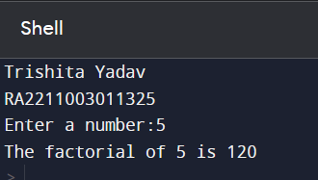

**4. Write a python program to Check if a Number is Even or Odd and also check whether it is Prime or not.**

def is_even(num):

return num % 2 == 0

def is_prime(num):

if num <= 1:

return False

elif num <= 3:

return True

elif num % 2 == 0 or num % 3 == 0:

return False

i = 5

while i * i <= num:

if num % i == 0 or num % (i + 2) == 0:

return False

i += 6

return True

def main():

print("Trishita Yadav\nRA2211003011325")

try:

num = int(input("Enter a number:"))

if is_even(num):

print(f"{num} is even.")

else:

print(f"{num} is odd.")

if is_prime(num):

print(f"{num} is prime.")

else:

print(f"{num} is not prime.")

except ValueError:

print("Invalid input")

main()

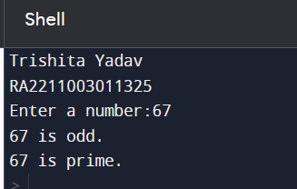

**5. Implement a python function to Reverse a given String and also check for palindrome or not.**

def is_palindrome(s):

s = s.replace(" ", "").lower()

# Check if the string is equal to its reverse

return s == s[::-1]

def reverse_string_and_check_palindrome():

# Input from the user

input_string = input("Enter a string:")

# Reverse the string

reversed_string = input_string[::-1]

# Check if it's a palindrome

if is_palindrome(input_string):

print(f"'{input_string}' is a palindrome.")

else:

print(f"'{input_string}' is not a palindrome.")

# Print the reversed string

print(f"Reversed string:{reversed_string}")

# Call the function

reverse_string_and_check_palindrome()

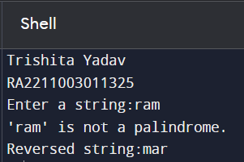

**6. Write a python program to Generate Fibonacci Sequence.**

print("Trishita Yadav\nRA2211003011325")

nterms = int(input("How many terms? "))

# first two terms

n1, n2 = 0, 1

count = 0

# check if the number of terms is valid

if nterms <= 0:

print("Please enter a positive integer")

# if there is only one term, return n1

elif nterms == 1:

print("Fibonacci sequence upto",nterms,":")

print(n1)

# generate fibonacci sequence

else:

print("Fibonacci sequence:")

while count < nterms:

print(n1)

nth = n1 + n2

# update values

n1 = n2

n2 = nth

count += 1

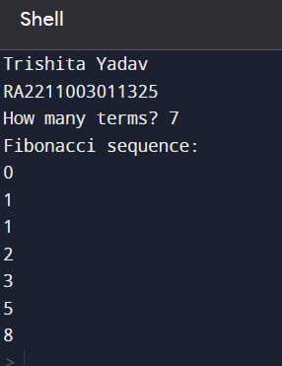

**7. Write a python program to calculate the area and perimeter of different geometric shapes (circle, rectangle, triangle, etc.).**

import math

def calculate_circle_area(radius):

return math.pi * radius*radius

def calculate_circle_perimeter(radius):

return 2 * math.pi * radius

def calculate_rectangle_area(length, width):

return length * width

def calculate_rectangle_perimeter(length, width):

return 2 * (length + width)

def calculate_triangle_area(base, height):

return 0.5 * base * height

def calculate_triangle_perimeter(side1, side2, side3):

return side1 + side2 + side3

def main():

print("Trishita Yadav\nRA2211003011325")

print("Choose a shape to calculate its area and perimeter:")

print("1. Circle")

print("2. Rectangle")

print("3. Triangle")

choice = int(input("Enter your choice (1/2/3):"))

if choice == 1:

radius = float(input("Enter the radius of the circle:"))

area = calculate_circle_area(radius)

perimeter = calculate_circle_perimeter(radius)

elif choice == 2:

length = float(input("Enter the length of the rectangle:"))

width = float(input("Enter the width of the rectangle:"))

area = calculate_rectangle_area(length, width)

perimeter = calculate_rectangle_perimeter(length, width)

elif choice == 3:

base = float(input("Enter the base of the triangle:"))

height = float(input("Enter the height of the triangle:"))

area = calculate_triangle_area(base, height)

side1 = float(input("Enter the length of side 1:"))

side2 = float(input("Enter the length of side 2:"))

side3 = float(input("Enter the length of side 3:"))

perimeter = calculate_triangle_perimeter(side1, side2, side3)

else:

print("Invalid choice")

return

print(f"Area:{area}")

print(f"Perimeter:{perimeter}")

main()

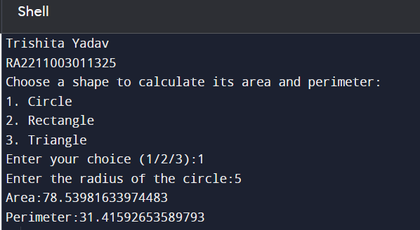

**8. Implement a python function to Convert Celsius to Fahrenheit and Fahrenheit to Celsius.**

def celsius_to_fahrenheit(celsius):

fahrenheit = (celsius * 9/5) + 32

return fahrenheit

def fahrenheit_to_celsius(fahrenheit):

celsius = (fahrenheit - 32) * 5/9

return celsius

def main():

print("Trishita Yadav\nRA2211003011325\n")

while True:

print("Choose an option:")

print("1. Convert Celsius to Fahrenheit")

print("2. Convert Fahrenheit to Celsius")

print("3. Quit")

choice = input("Enter your choice (1/2/3):")

if choice == '1':

celsius = float(input("Enter temperature in Celsius:"))

fahrenheit = celsius_to_fahrenheit(celsius)

print(f"{celsius}°C is equal to {fahrenheit}°F\n")

elif choice == '2':

fahrenheit = float(input("Enter temperature in Fahrenheit:"))

celsius = fahrenheit_to_celsius(fahrenheit)

print(f"{fahrenheit}°F is equal to {celsius}°C\n")

elif choice == '3':

break

else:

print("Invalid choice. Please select a valid option.")

main()

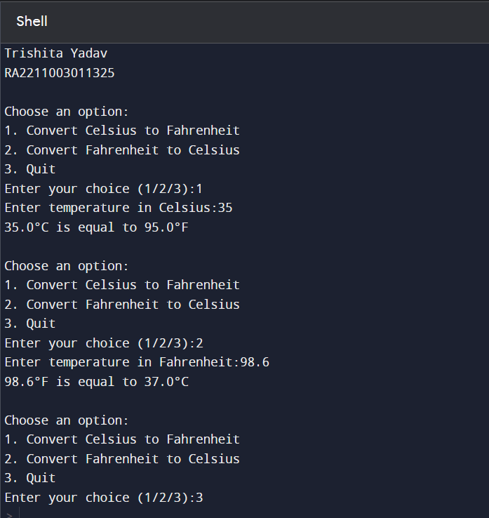

**9. Write a Python program that accepts a string and counts the number of upper and lower case letters.**

def count_upper_lower_case_letters(input_string):

upper_count = 0

lower_count = 0

for char in input_string:

if char.isupper():

upper_count += 1

elif char.islower():

lower_count += 1

return upper_count, lower_count

def main():

print("Trishita Yadav\nRA2211003011325")

input_string = input("Enter a string:")

upper_count, lower_count = count_upper_lower_case_letters(input_string)

print(f"Number of uppercase letters:{upper_count}")

print(f"Number of lowercase letters:{lower_count}")

main()

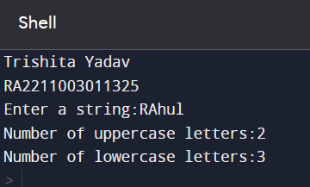

**10. Write a python program to perform Arithmetic operations on Complex Numbers.**

def main():

print("Trishita Yadav\nRA2211003011325")

# Get the first complex number from the user

real1 = float(input("Enter the real part of the first complex number: "))

imag1 = float(input("Enter the imaginary part of the first complex number: "))

complex1 = complex(real1, imag1)

# Get the second complex number from the user

real2 = float(input("Enter the real part of the second complex number: "))

imag2 = float(input("Enter the imaginary part of the second complex number: "))

complex2 = complex(real2, imag2)

# Perform arithmetic operations

addition_result = complex1 + complex2

subtraction_result = complex1 - complex2

multiplication_result = complex1 * complex2

# Division is a bit more involved

try:

division_result = complex1 / complex2

except ZeroDivisionError:

division_result = "Division by zero is not allowed."

# Display the results

print(f"Complex Number 1: {complex1}")

print(f"Complex Number 2: {complex2}")

print(f"Addition Result: {addition_result}")

print(f"Subtraction Result: {subtraction_result}")

print(f"Multiplication Result: {multiplication_result}")

print(f"Division Result: {division_result}")

main()

